**E-PROJECT: whoZThat**

**whoZThat**

**Developer Guide**

|  |  |  |
| --- | --- | --- |
| **SUPERVISOR** | SIR TAHA ABBAS | |
| **BATCH CODE** | 2501B2 | |
| **Group** | B | |
| **Serial no** | **ENROLLMENT No** | **STUDENT NAME** |
| **1** | STUDENT1633780 | ABDULLAH |
| **2** | STUDENT1636167 | ABDULLAH AZAAM |
|  | | |

**E-PROJECT: whoZThat**

**HOME PAGE**

**SECTION OF NAVBAR**



**CODE OF NAVBAR**

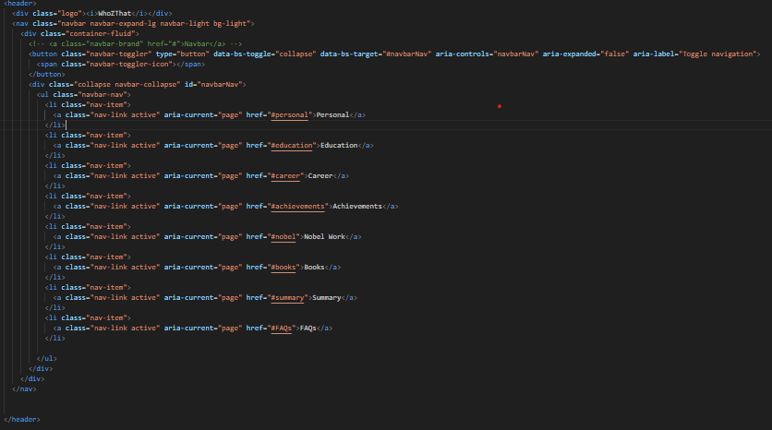

**E-PROJECT: whoZThat**

**SECTION OF PERSONAL**

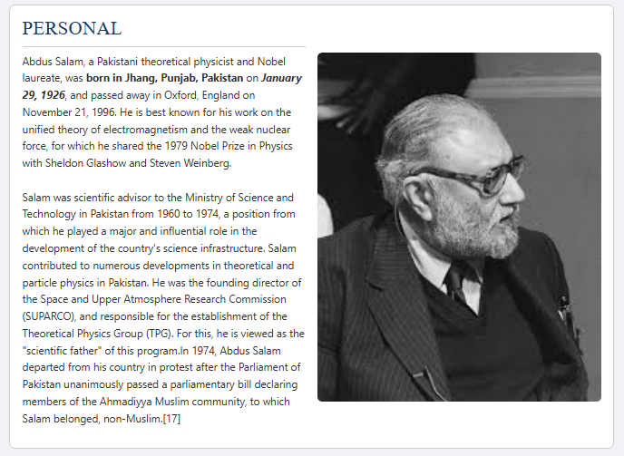

**CODE OF PERSONAL**

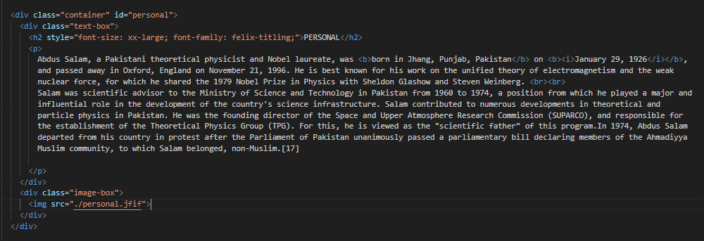

**E-PROJECT: whoZThat**

**SECTION OF EDUCATION**

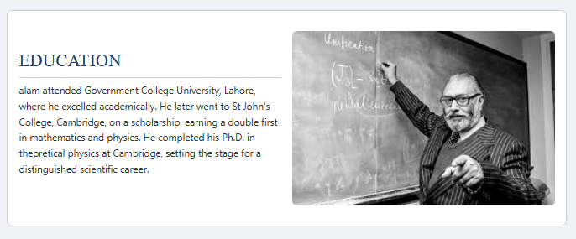

**CODE OF EDUCATION**

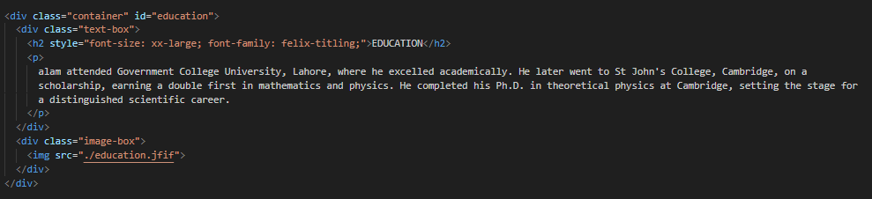

**E-PROJECT: whoZThat**

**SECTION OF CAREER**

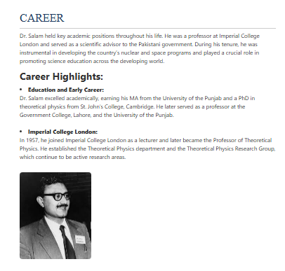

**CODE OF CAREER**

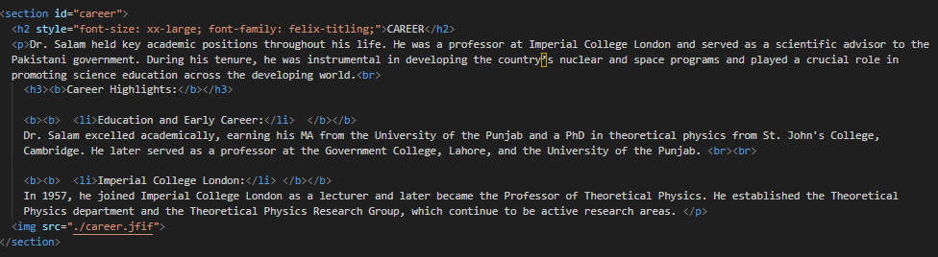

**E-PROJECT: whoZThat**

**SECTION OF ACHIEVEMENTS**

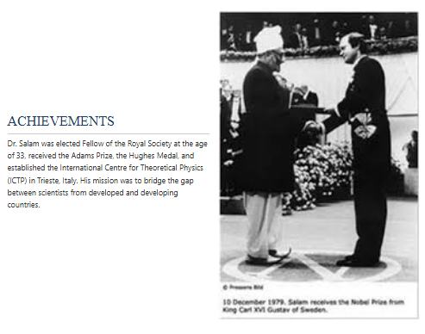

**CODE OF ACHIEVEMENTS**

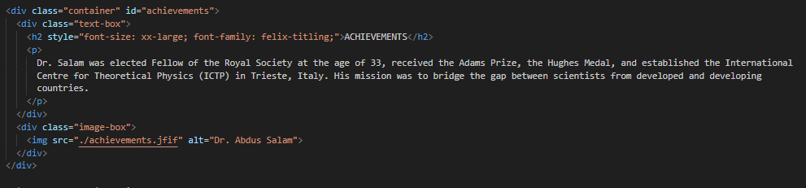

**E-PROJECT: whoZThat**

**SECTION OF NOBLE WORK**

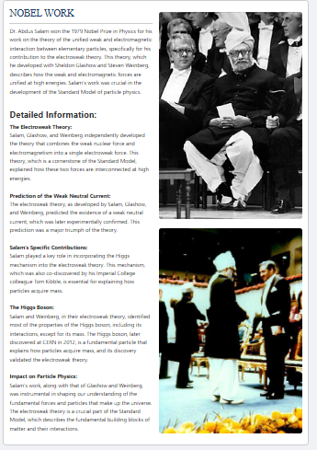

**Code of noble work**

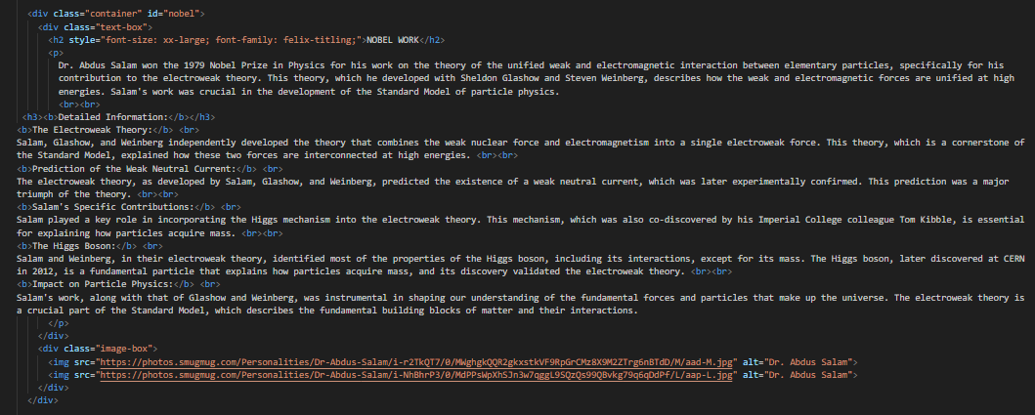

**E-PROJECT: whoZThat**

**SECTION OF BOOKS**

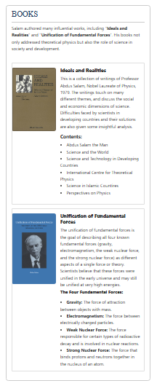

**CODE OF BOOKS**

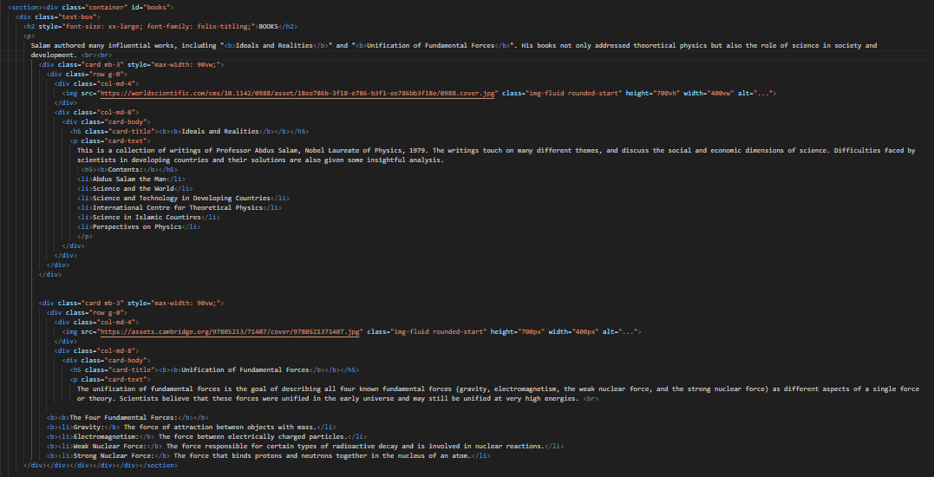

**E-PROJECT: whoZThat**

**SECTION OF SUMMARY**

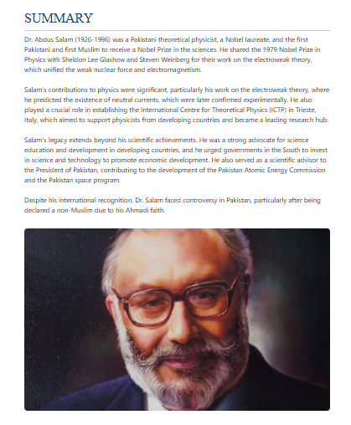

**CODE OF SUMMARY SECTION**

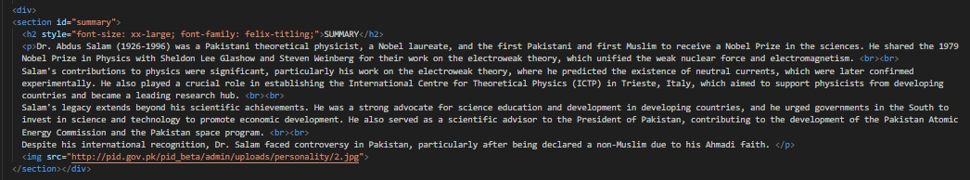

**E-PROJECT: whoZThat**

**SECTION OF FAQS**

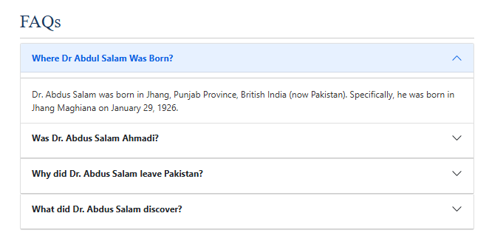

**CODE OF FAQS**

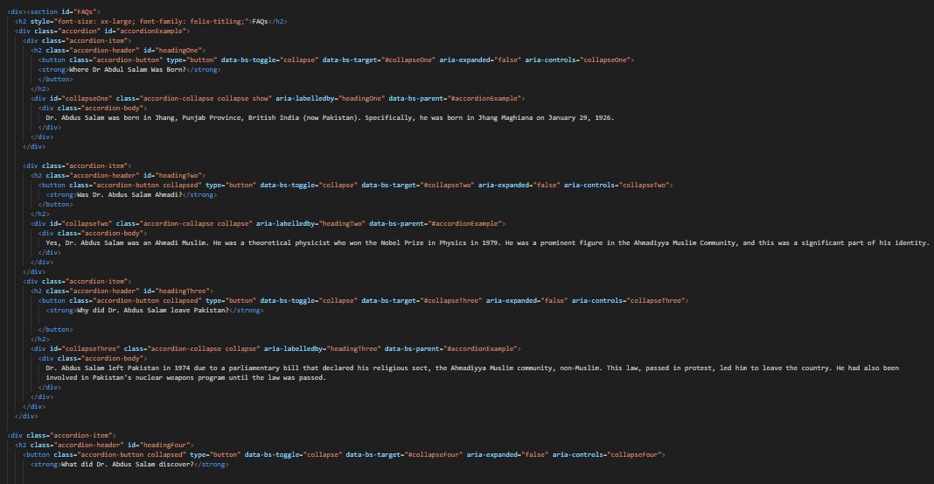

**E-PROJECT: whoZThat**

**SECTION OF FEEDBACK FORM**

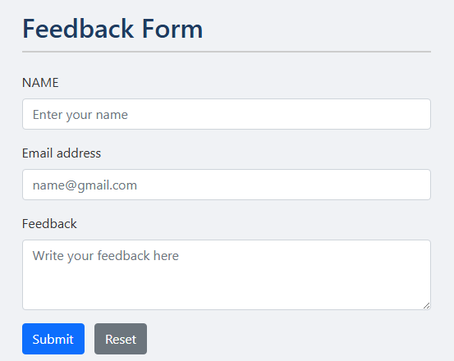

**CODE OF FEEDBACK FORM**

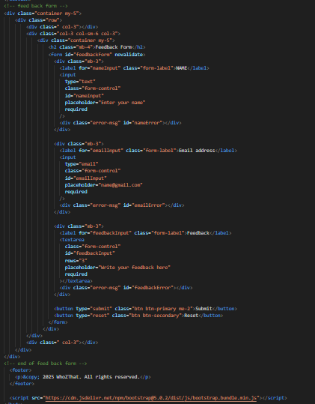

**E-PROJECT: whoZThat**

**SECTION OF FOOTER**

**CODE OF FOOTER**